|  |  |
| --- | --- |
|  | **Will of the Wood** |
|  | **Game Design Document *v0.03*** |
|  | **5 Dec 2019** |

# Table of Contents

Table of Contents **2**

Change Log **4**

Executive Summary **5**

Description 5

Features 5

Project Goals 5

License Integrity 5

Visual Treatment 5

Gameplay Overview 5

Player Objectives 6

Game Modes 6

First 5 Minutes 6

Story 6

Informational HUD Elements 7

Interactive HUD Elements 7

“Options”, “Text”, “World Map” and “Character Sheet” Buttons 7

Animations and Transitions 8

Loading Screen 8

Level Screen Animations: 8

In-Game Visual Feedback 9

Gameplay **9**

Intro Scene 9

Details. 9

Character Interactions 9

Special Features 10

Abilities, Spells and Items 10

Levels and Stages 10

Area Completion Overview Chart 12

Boss Battles 13

Weapons 15

Armor 15

Gaining Experience 15

Experience System (Chart): 15

Attributes and other Statistics 15

**Abilities & Spells** **16**

Front End **24**

Main Menu Flow 24

Main Menu 24

Character Creation 24

Load Game 24

Options Menus 25

Pause Menu Flow 25

Resume 25

Save Game 25

Load Game 26

Content **26**

Character Animations 26

NPC List 26

SFX Assets 27

Stages 28

Controls **29**

Layout and Description 29

Controls Overview 29

Marketing **29**

Short Descriptions/Taglines 29

Positioning Strengths 30

Target Audience 30

# Change Log

|  |  |  |  |
| --- | --- | --- | --- |
| ***Version*** | **Changes** | **Changed By** | **Date** |
| ***0.01*** | ***Changed the name of the Options menu to the Pause Menu*** | ***TO*** | ***26-Apr-19*** |
| ***0.01*** | ***A New area has been added (The Death Prince’s Burial Mound)*** | ***TO*** | ***26-Apr-19*** |
| ***0.01*** | ***The Death Prince has been renamed The Dark Prince*** | ***TO*** | ***28-Apr-19*** |
| ***0.02*** | ***+1 Temporary Corruption while in the Dark Prince’s Burial Mound*** | ***TO*** | ***8-May-19*** |
| ***0.02*** | ***Inclusion of the Cathedral of Light*** | ***TO*** | ***8-May-19*** |
| ***0.02*** | ***Inclusion of pathway blocking benches in the Cathedral of Light*** | ***TO*** | ***9-May-19*** |
| ***0.02*** | ***Adjusted the XP rewards chart*** | ***TO*** | ***9-May-19*** |
| ***0.03*** | ***Changed player stats to updated in-game version*** | ***MS*** | ***10-Dec-19*** |
| ***0.03*** | ***Player input controls were updated to match in-game*** | ***JG*** | ***10-Dec-19*** |

# Executive Summary

## Description

Will of the Woods is a third person Role-Playing Game where the players build up they’re character’s abilities while interacting with colourful characters in a dark themed setting. The player controls a Main Character while exploring a town in a fantasy setting. The player has arrived during a bloody conflict between the town and the horrid creatures from the nearby woods. The player will need to discover the secrets of the setting or they and the town are doomed to die within 7 days.

## Features

* A fast paced combat system based on the Roleplaying Game SYMBAROUM by Free League Games.
* A variety of settings that alter depending on time and the player’s very actions
* NPCs that respond to the actions of the players and whose attitudes may develop throughout the course of the game based on player choices.
* A cumulative final battle that takes into account all of the player’s past actions and see if their efforts were enough to turn the tide and save the town

## Project Goals

The goal of this project is to take the best aspects of the Symbaroum system and accentuate them to gain the maximum amount of interest. Magic and ranged weapons have been removed entirely so that the project can focus on making the player’s swordplay as captivating as we are able to within our deadline. This is a challenging game that offers a great deal of replayability thanks to the incredible amount of choice available to the player. If the character dies within the allotted time, they are forced to restart from day 1, this unforgiving style will ratchet up the player’s interest to try again and see if there was something new they can try and explore new areas of the game. Ideally, there should be more content for the player to explore than there is time in the game. This will further the replayability of the game.

### Visual Treatment

The settings of the game are dark and gloomy yet they are to be colourful and interesting to the eye. During the day all assets will be drawn in realistic colour schemes but at night the settings become more colourful. Trees and foliage will be dark but underlit by green-blue spectral fey colours. Building exteriors are to be in a medieval style with chipping, cream coloured plasters and dark beams and rooftops. The shingles of important buildings will be different colours to be more easily recognisable. The ground is either drab cobblestone or earthy browns to make PC, NPCs and collectables easier to see.

The character models each look unique so they can be easily distinguished when they are in a group. Ally NPCs (when combat begins) have a subtle white glow to make them more easily recognisable as friendly units. Enemy NPCs (regardless of their other characteristics) have a subtle red glow to denote them as threats to the player. NPCs that aren’t interactable are non-descript in appearance and wear simple greys and browns.

## Gameplay Overview

Gameplay in Will of the Woods is equally driven by conversing with NPCs as it is combat. When combat is entered, the player will be forced to maneuver around the battlefield and avoid the enemies attacks. When they player strikes enemies, or is struck by them, a random to-hit system is run to see if they are able to avoid it or damage is taken. During conversations, the player approaches the NPC they wish to talk to and that character will respond to the character in the Text Box. The character may then choose what they say in response from a pool of answers the game then offers in the Text Box. This process continues until the player no longer wishes to converse with the NPC. Succeeding at killing monsters or progressing the story through conversations earns experience points which can be used to improve the characters statistics.

### Player Objectives

1. Repelling the elves’ inevitable attack on the town of Thorngard by finding allies, harassing the elven ranks and strengthening Thorngard with supplies
2. Stop the wicked Priest, Father Sarek, who is hoarding the towns supplies within the church to protect his faithful followers.
3. Track down the Witch Thaelda for Father Sarek who will convince the people of Thorngard to abandon the witch in the wilds to be killed by the elves.
4. Contact the Witch Thaelda and use who to get in contact with the more reasonable elves and convince them to abandon this war.
5. Progress Side Quests to Empower the Player with new abilities and weapons.

### Game Modes

**Story Mode:**

The player is a treasure hunter that come to the town of Thorngard. The town is being harassed by elves of the great forest to the north. Players are quickly discover a massacre by the elves as they approach Thorngard. Thorngard is a town divided and the Player must choose whose side they are to take, although, players may choose to change their alignments throughout the game. Players must learn more about these characters and learn their secrets in order to build up Thorngard’s defenses if there is any hope of surviving the coming elves. Throughout the game, monsters will leave the forest and threaten the people of Thorngard.

## First 5 Minutes

When the game boots up, the player’s Main Character is on the road to a town. They are standing on a dirt road with hip high stone walls flanking its sides. There is the sound of birds singing and soft, pleasant, music playing. Within a few seconds the characters come upon a disturbing scene. The road opens slightly and there is the bloody carnage of a battle. The player will have the option of taking some supplies from an overturned cart, later being able to choose if they return these supplies or keep them for themselves. When this scene is illuminated the music darkens to a more disturbing melody. The player may then continue down the road where they encounter some rough looking townsfolk of Thorngard, brigands most like. They explain how their town, Thorngard, has enough trouble without vagabonds. The player has some choices in what to say in response, all of which appear in the text box, but all options lead to a combat with the ruffians. These enemies are no match for the player. Right before combat, the game pauses and prompts display the basics of combat. Following the combat, the player soon comes upon an NPC dressed as a jester and says he’s called Rook, the Minstrel. He explains about the town plight with the elves. He doesn’t want to talk in the open like this and he asks them to meet him at the tavern. The Tavern is the very first building the player will see, easily identifiable by a big sign with a tankard of ale out front. They pass a number trees, their leaves are dark green with pale grey trunks. As they move, little eyes will appear in shadowy places before disappearing, the nearby objects moving as if something had bumped into them. This is a persistent feature throughout the game. The building has white plaster veneer that is chipped in places, revealing the bricks underneath. Dark timber supports the red shingled roof.

## Story

You are the only one capable of thwarting the wicked beasts of the dark forest who have come to hunt the people of Thorngard, that is, if you can prevent its people turning on each other first. Informational HUD Elements

* There is an old fashioned **compass** in the very top right of the map. Around this map there is a dial that also shows whether its day or night.

## Interactive HUD Elements

* In the top right there is a **Mini Map** of the nearby area. This map will show areas that the player character has seen but areas not yet visited will be blacked out.

### “Options”, “Text”, “World Map” and “Character Sheet” Buttons

* **Options Button**: Located in the bottom right above the World Map button. This opens the in-game Pause Menu. While this screen is up the gameplay is paused
  + This brings up the Pause Menu where there include the buttons to: Save, Load, edit the graphics etc.
* **Text**: Located in the bottom right above the Options Button. This opens the in-game Text Box. This button appears as a grey box with the words *Text Box* written in black text.
  + This menu appears as a black box at the bottom of the screen, which appears overtop of the Party Tiles. When players wish to converse with NPCs, the NPC’s speech will be written in this box. There are numerous instances where the player will be given a number of options to respond to what an NPC has said. This area is also used to give descriptions of objects that the player chooses to investigate. This box disappears when not in use. Everything that appears in this box, remains there for the entirety of the game, and the player may scroll up through the text to see what has appeared there in the past.
* **World Map**: The World Map button is located In the bottom right, above the Text Box button. It has the symbol of a treasure map.
  + The world map is a creamy parchment coloured map with locations depicted in brown ink in an ancient design. Hovering the mouse over key locations brings up a black box that gives a brief description of that area.
* **Character Sheet Button**:The Character Sheet can be reached by clicking on the desired character’s Party Tile.
  + The character sheet displays the character’s eight Attributes: Accurate, Cunning, Discreet, Persuasive, Quick, Strong, and Vigilant. These eight attributes are in boxes along the top of the Character Sheet in two rows of four with their respective values listed underneath. There is a portrait of the selected character on the top left of the Character Sheet. Beneath this character sheet is a list of all the character’s Abilities. Hovering the mouse over the names of these Abilities brings up a box that explains what that Ability does. In the bottom right there is a grid that displays that character’s inventory.

## In-Game Visual Feedback

* **Gameplay Feedback:**
  + A door that leads to a new instance has a seam of light glowing through the cracks.
  + A door that is closed blocks the party’s line of sight.
* **Successful or Failed Actions**
  + Successfully damaging an enemy with a physical attack is followed by a bloody spray of blood. The enemy unit staggers.
  + Failure to damage an enemy with a physical attack causes the attacker to stagger.
  + When an unlocked door is open, it swings open, unless that door leads to a separate Instance. If that door opens a separate instance, the door cracks open a little and light spills out from the new area.
  + Any locked door that is attempted to be opened jiggles a little, but remains closed.
  + An unlocked chest flips open when opened.
  + Locked chests that are attempted to be opened jiggles a little, but remains closed.
* **Scoring Feedback:**
  + When a character has earned enough XP to improve their character a sound like windchymes will sound and the character’s Party Tile will have the words *Level Up* in glowing white letters.

# Gameplay

The gameplay revolves around the player using the mouse and WASD keys, or controller, to move in and out of enemy range to attack they while avoiding taking hits themselves. If the player wishes to attack an enemy, the player needs only to left click or press the attack button on the controller. There are a number of Abilities that the player will be able to access throughout the game to augment combat and how they approach enemies. Some of these Abilities are passive while others are activated. The quicking access the activated Abilities, the player can cycle through their Activatable Abilities at the top with either the scroll wheel or the controller triggers. When the desired Ability is selected, press either right click or the right bumper to activate it. A number of combat situations can be subverted by cunning players that select the correct conversation pathway through chats with NPCs. If the main character dies, the game is over. If the character isn’t able to complete enough objectives before 7 days expires, in game time, then there will be a hellish final battle awaiting them.

## Intro Scene

There is an introductory cutscene, it is a simple affair with the camera sweeping over a medieval kingdom, swooping over a great forest before zooming in on a road beside the woods. While the cutscene is playing there is a woman’s voice narrating the general recent history of this land, and describing the goings on of the town “Thorngard”, the setting of the game. The player is then given control of his Main Character and he begins playing the game proper.

### Details.

* As the camera flies over the forest, there are moving shadows and glimpses of horrid creatures as well as a band of pale skinned elves moving between the branches.
* When the camera settles on the town Thorngard, there is a chimney of smoke coming from the outskirts of town and, if you look closely, you can see a blood battlefield ahead on the road..

## Character Interactions

* You may speak to any character in the game by left clicking that character while near enough, or hitting the action button on the controller. When a chat begins, the Text Box pops up which has what that character is saying written out. Beneath what they have said, there are a number of options for what the player may respond with. When combat begins, NPCs are no longer able to communicate until combat ends. For non-crucial NPCs these conversations don’t yield much. The player’s choice of response may alter the disposition of that character towards the Main Character. These crucial character are as follows:
  + **Rook, The Minstrel**
  + **Father Sarek**
  + **Thaelda**

## Abilities and Items

* As the player kills monsters and progresses the story through conversations, they gain XP that can be used to buy **Abilities**. These are special features that allow the player to interact with the gameworld beyond fighting and conversing with NPCs. Some Abilities may augment both combat and conversations.
* There are generic weapons in the game. While it is possible to enter combat with only your fists, the use of any form of mundane weapon offers a far superior benefit.
* There are elven weapons in the game. These function as generic weapons but deal slightly more damage.
* There are magic weapons in the game. Magic weapons do more damage than generic weapons, and sometimes add additional benefits. Magic weapons are rare in the game so players will need to do some hunting to find these artifacts.
* There are generic sets of armour in the game. It is completely possible, and sometimes preferable, to enter combat without armour. Armour makes it easier for enemies to hit you, but when you are hit a portion of the damage they do is negated based on what type of armour you’re wearing.
* There are magic sets of armour in the game. Magic armour can offer a wide variety of bonuses from simply absorbing more damage, to making the character harder to hit, to more unique abilities. Magic armour is rare in the game so player’s will have to decide carefully who should wear magic armour.

## Levels and Stages

* **Thorngard**: The hub world of the game. There are numerous non-crucial NPCs wandering around this area, entering and exiting buildings, stopping at some of the vendors and such. As the game progresses, fewer and fewer of these NPCs will be present as the townsfolk are slowly being killed off. There is a central market area that has a number of vendors where the player can buy foodstuffs but not much else. The first building players see when entering Thorngard is the town’s inn, *The Merry Goblin* (usually pronouned “Gobbin”). At the Gobbinthe player may buy food or rent a room for the night. Sleeping moves time forward 8 hours. The Merry Goblin’s NPC owner, *Aadhn*, can always be found here. A couple doors down from the inn is the blacksmith’s shop, *Harmond’s Forge*, where the player may buy and sell weapons and armour. The forge’s NPC owner, *Harmond*, can be found here during the day hammering the anvil. To the south of the town, beyond any buildings there is an area referred to as, *the Outskirts*, this is where the player begins the game. There isn’t anything to interact with here, the only thing of note here is the bloody battlefield they saw at the beginning. To the north of town, there is a break in the buildings where the player may enter and leave Thorngard. In the western part of town there is the *Cathedral of Light*, the church of Thorngard. *Father Sarek* may usually be found here.
* **The Farmlands:** Here there is dirt roads, flanked by stone walls. Behind these walls there are golden fields of grain. The road branches off and leads to three separate farmhouses. During the day, the fields have wandering NPCs working but they are empty at night. There is a random chance of monsters randomly spawning when the player enters the farmlands.
* **The Forest:** A large forested area with all manner of hidden locales and enemies waiting to jump the player. Among these are Elven Outpost, where the player has a chance to slay some elves and hinder the Final Battle on the 7th day. The outposts are small positions but possess numerous guardians. If the characters become allies of the more reasonable elves, then they can approach an Elven NPC, *Ulendry*, who is willing to sell elven weapons to the player. When this option becomes available, when the player approaches Ulrendy, the roots of the nearby tree come alive and raise up, revealing a weapon cache.
* **The Deep Forest:** Far more dangerous than The Forest, this area is populated by yet more monsters, but also some well hidden items that might aide the player and his quest. It is difficult to see in here, the enemies are able to sneak up real close and surprise the player if they are not extraordinary vigilant.

## Area Completion Overview Chart

|  |  |  |  |  |  |  |
| --- | --- | --- | --- | --- | --- | --- |
|  | **XP Gaining Conditions** | **Loss Conditions** | | **Special Features?** | **Items** | **Other Elements** |
| **Area 1: Thorngard** | | | | | | |
|  | *Kill Father Sarek  *Convince Thorngard to turn on Sarek  *Kill Thaelda  *Prove Thaelda is a witch  *Discover the location of the Elven Hall  *Bring “Ikol’s Head” item to Tulyela’s Mother  *Reforge the Blackblade | *Main Character dies  *Game Over in 7 days (game time) | |  | *Purchase Generic Weapons and Armour  *The Blackblade | *3 searchable objects with 10 thaler (gold) each  *Searchable floorboard with 6 thaler |
| **Area 2: The Farmlands** | | | | | | |
|  | *Save Tulyela  *Discover the location of the elves Court  *Kill Randomly Spawned Enemies  *Discover the Hidden elves  *Learn that the barmaid, Maggie, keeps her money under the floorboards of *The Thirsty Pilgrim*. | *Main Character dies  *Game Over in 7 days (game time) | |  | *Random loot on Randomly Spawned Enemies | *2 searchable objects with 20 thaler (gold)  *Random 1-6 thaler on Randomly Spawned Enemies |
| **Area 3: The Forest** | | | | | | |
|  | *Kill Elves  *Kill all Elven Enemies  *Kill Elven Mini-boss (Ulrendy)  *Convince Reasonable Elves to leave Thorngard in peace | *Main Character dies  *Game Over in 7 days (game time) | |  | *Player’s Choice of Elven weapons (If Allied with Elves)  *4 Random Elven weapons on Elf Bodies |  |
| **Area 4: The Deep Forest** | | | | | | |
|  | *Kill spider  *Kill mini-boss (Ikol)  *Read Ikol’s Journal  *Make peace with Ikol  *Find the dead mage’s corpse  *Kill trapped Spring Elf  *Free trapped Spring Elf  *Destroy Spider Egg Sacs | *Main Character dies  *Game Over in 7 days (game time) | |  | *Ikol’s Head  *Ikol’s Journal  *Tattered Spellbook  *The Blackblade (Blade Shard) (magic sword) | *14 searchable objects with 1-4 random thaler |
| **Area 6: The Elven Hall** | | | | | | |
|  | *Kill an Elf | *Main Character dies  *Game Over in 7 days (game time) | | *elves are invisible unless Main Character washes their eyes in the pond | *The blackblade (Hilt)(magic sword) |  |

## Boss Battles

* **Father Sarek,** (Optional)**:** The boss battle with Father Sarek is a simple affair, the battle begins with Father Sarek speaking to the Main Character. Depending on the player’s choice of response, the combat may potentially be avoided and Sarek will surrender. Otherwise, the party characters are thrown from his side by a magical blast of energy and the player will have to fight across the room to get to Father Sarek. A number of zealot NPCs emerge from the cloisters of the map and start fighting the player. All the while, Father Sarek is throwing damaging Mythical Powers across the room at the party. Sarek focuses on the Main Character’s companions first, and attempts to kill the Main Character last. The arena is set in the main area of worship in the *Cathedral of Light*. There are benches that impede movement, forcing the player down long ilse to get to the boss. Father Sarek doesn’t have much armour and lacks a weapon to properly fight in melee. If the player is able to maneuver his party into close combat, Sarek can quickly be dispatched.
* **Thaelda** (Optional): The boss battle with Thaelda is a very simple affair. The battle arena is set in Thaelda’s shack, in the basement, a very tight and confined space. The battle begins with Thaelda talking to the Main Character. Depending on the player’s choice of response, the combat may potentially be avoided and Thaelda will be allowed to flee. Otherwise, Thaelda lets out a burst of power that throws the Main Character and the party outward. She then casts a spell that locks down (moving roots that entangle) a random number of the party, preventing them from moving, attacking or casting Mythical Powers. Thaelda then transforms into a horned bear creature. In this new form, Thaelda has vastly improved armour rating and a powerful claw attack. Fighting Thaelda in melee combat is now exceptionally dangerous. Thaelda will focus locked down characters first. If no characters are locked down, Thaelda attacks the character with the least health.
* **Ulrendy** (Optional): The battle begins with Ulrendy talking to the Main Character. Depending on the player’s choice of response, the combat may potentially be avoided, however, this is most challenging. To avoid combat, the player must have released the trapped Spring Elf in the Spider Den, allied themselves with Thaelda, and read the tome *Tongue of Ylhurandy* in the vaults of *The Cathedral of Light*. Otherwise, Ulrendy attacks the player. The Forest is the battle’s arena. It is a circular room with thickets and fallen trees marking the borders for the area. There are a number of trees blocking movement through the middle of the space. Ulrendy is a very mobile enemy, riding atop a giant elk, he charges the player’s party before retreated to charge again. While Ulrendy is moving in and out of combat, the other elves in the arena move into combat or pepper the party with arrows.
* **Ikol**: The battle begins with Ikol talking to the Main Character. Depending on the player’s choice of response, the combat may potentially be avoided, however, this is most challenging. If the player has destroyed 6 of the *Spider Egg Sacs* in the *Spider Den*, then Ikol cannot be reasoned with. Ikol begins by burrowing into the arena’s floor and reappearing on the farthest corner of the room. Three large spiders then burrow up from the floor and start fighting the player. From across the room, Ikol will spew a stream of venom that will poison party members it hits. The player will need to move their party strategically to avoid the spray. If the spray hits any party member, that character is poisoned. Walking through an area with poison on the ground, also poisons the character. After this ranged attack, Ikol will charge in and attack, focusing on the Main Character. Once one third of Ikol’s health is gone, Ikol disappears into the ceiling by crawling up a spider web. He will reappear in the opposite corner of the arena, throwing a string of wed at the nearest player party member. If this web hits a party member, that player is dragged closer to Ikol while three more spiders burrow up from the ground to hold up the rest of the party. When only one third of his health, Ikol again attempts to “hook” another party member after disappearing into the ceiling and reappearing.

## Weapons

* Shortsword - deals 1-6 damage short
* Sword - deals 1-8 damage
* Greatsword - deals 1-10 damage long
* The Blackblade - deals 4-15 damage
* Short Spear - deals 1-8 damage
* Longspear - deals 1-10 damage
* Club - deals 1-6 damage short
* Mace - deal 1-8 damage

## Armor

* Padded Shirt - reduces incoming damage by 1-4
* Boiled - Cuirass reduces incoming damage by 1-6
* Mail - reduces incoming damage by 1-8
* Elven Armour - reduces incoming damage by 1-8
* Dark Prince’s Death Shroud - reduces incoming damage by 4-11

## Gaining Experience

Details.

Are variables **tunable PER level**? Or global for every level?

### Experience System (Chart):

|  |  |
| --- | --- |
|  | **Points Awarded** |
| **Success** |
| **Killing Enemies** | |
| **Killing Weak Enemies** | 1/100 |
| **Killing Ordinary Enemies** | 1/10 |
| **Killing Challenging Enemies** | 1 |
| **Killing Strong Enemies** | 3 |
| **Killing Mighty Enemies** | 6 |
| **Killing Legendary Enemies** | 10 |
| **Conversations** | |
| **Minor Conversations** | 1/10 |
| **Major Conversations** | 1 |
| **Avoidance Combat** | XP = to reward if player had killed the enemy |

## Attributes and other Statistics

|  |  |  |
| --- | --- | --- |
| **Stat** | **Description** | **Notes** |

|  |  |  |
| --- | --- | --- |
| **Accuracy** | Main stat that dictates whether or not an attack lands successfully |  |
| **Speed** | Main stat that dictates player move speed and whether or not an enemy attack hits the player |  |
| **Strength** | Main stat that dictates the players healthpool and resistance to being stunned |  |
| **Discretion** | Main stat used to lower the enemies’ line of sight (vision range + cone angle) |  |

|  |  |  |
| --- | --- | --- |
| **Persuasive** | Secondary stat used for conversational skill checks |  |
| **Defense** | Secondary stat influenced by Speed, determines “dodge” chance of the player |  |
| **Pain Threshold** | Secondary stat that is indicative of how resilient the player is to being stunned by an enemy | ⅕ max hp vs normal enemy  ½ max hp vs boss |

# Abilities & Spells

The Player may buy abilities using Experience Points. They may choose to improve an Ability they already possess or purchase a new one at Novice Level. A Novice Level Ability costs 10 Experience points. To improve a Novice to an Adept Level Ability it costs 20, and to improve an Adept into a Master it costs 30 Experience Points.

**Upgrades List:**

|  |  |
| --- | --- |
| **Ability** | **Gameplay Impact** |
|  |  |
| **Backstab** | Novice: An attack against a target it didn't see takes 1-4 extra damage. This attack uses Discreet instead of Accurate.  Adept: The attack as above causes a bleeding wound. The enemy suffers 1-4 damage each turn following the attack. This effect continues until they are healed.  Master: The attack above now does 1-8 extra damage. Backstab now works so long as the character is attacking the target's back. |
| **Berserker** | Novice: Character may toggle this ability on or off. While on they deal 1-6 extra damage when fighting in melee combat. Their Quick is considered to be 5 when calculating Defense.  Adept: While in rage, the character ignores 1-4 damage from each hit suffers.  Master: While in a rage, the character's Quick is no longer considered 5 when determining Defense. |
| **Dominate** | Novice:  The character's Persuasive Attribute is used instead of Accurate in melee combat.  Adept: A targeted ability that, with a successful [Persuasive←Resolute] test, to target another viable target for the next 6 seconds.  Master: A targeted ability, the character can force a target enemy to flee in terror for 25 seconds with a successful [Persuasive←Resolute] test. The enemy must first be wounded by a party member before it can be targeted. |
| **Exceptional Attribute** | Novice: Permanent +1 to Attribute of choice.   Adept: Increase bonus from +1 to +2.  Master: Increase bonus from +2 to +3. |
| **Feint** | Novice: Character can chooseto attack with Discreet instead of Accurate when the attack is made with a melee weapon which is either Short or Precise.  Adept: The character uses Discreet instead of Quick to determine Defense.  Master: At random times during combat, anywhere between 6-12 seconds, a [Discreet←Vigilant] test is made and if that is a success, the Character’s next attack with a Short or Precise weapon does an addition 1-8 damage. |
| **Iron Fist** | Novice: The character uses Strong instead of Accurate then making a melee attack.  Adept: All melee attacks do an extra 1-4 damage.  Master: The first attack a character does every 6 seconds, the bonus damage from the Adept level increases 1-8. |
| **Man-at-Arms** | Novice: Armour this character wear improves its armour rating by one tier. Light armor blocks 1-6, medium armor blocks 1-8 and heavy armor now blocks 1-10.  Adept: While wearing Armour, the character has a 1 in 10 chance of knocking the enemy down as their attack is turned upon the character’s armour.   Master: A Quick test is done to counteract effects from Abilities or equipment that ignore or reduce the character’s Armor value. A successful test means the armour protects as usual. |
| **Natural Warrior** | Novice: Unarmed attacks now deal 1D6 damage.  Adept: When the character makes an unarmed attack, they attack twice.  Master: Unarmed attacks deals 1-6 extra damage. |
| **Poisoner** | Novice: A successful Cunning test allows character to apply one dose of poison or other alchemical elixir to a weapon. Enemies struck by the *first* attack with that weapon are poisoned. A [Cunning←Strong] test is performed until the victim succeeds or they die. The damage done is determined by the strength of poison.  Adept: The poison on a weapon now affects all attacks that weapon strikes until combat ends.  Master: When apply poison to a weapon, a Cunning test is made. On a success, the applied poison is treated as one degree more damaging, except for Strong Poisons which instead give the character a second chance to succeed on the [Cunning←Strong]. |
| **Polearm Mastery** | Novice: Weapons with the Long attribute deal one step more damage. 1-10 for spears and halberds to 1-8 for staves.  Adept: This character gets a free attack on enemies when they come into range. Enemies that are wielding Long weapons as well are immune to this effect.  Master: Whenever the free attack from Adept hits, even if no damage is done, that enemy isn’t able to move close enough to attack. |
| **Recovery** | Novice: The character regains 1-4 Toughness.  Adept: Character now regains 1-6 Toughness.  Master: Character now regains 1-8 Toughness. |
| **Shield Fighter** | Novice: Passive. The damage dealt by weapons held in the character’s sword arm is increased by one step; to 1D10 if the character fights with a single-handed weapon or to 1D8 if using a Short weapon. The Novice Shield Fighter wields its shield as an instrument of protection with greater efficiency and therefore receives a +2 Defense bonus instead of the usual +1 when using a shield.  Adept: Reaction. The character has learned how to combine weapon and shield so well that every successful attack may be followed up by a shield bash against the same target. The damage of the shield bash is 1D4, and should the character make a successful die roll against [Strong←Strong] the target is also knocked to the ground.  Master: Reaction. The damage of the shield bash is increased from 1D4 to 1D8 and the target is still knocked to the ground if the character succeeds with a [Strong←Strong] test. |
| **Steadfast** | Novice: When trying to resist an an ongoing physical effect using a Strong test, the character receives a second attempt. This includes some effects from mystical powers.  Adept: Character now gets a second attempt to shrug off all status effects, poison, knockdown, etc  Master: Whenever the character succeeds a test based off of Vigilance, the attacker suffers 1-6 damage that ignores Armour |
| **Twin Attack** | Novice: The character can wield two weapons now. The character can make two attacks on the same target, dealing 1-8 and 1-6 damage respectively. They also gain +1 to their Defense when wielding a weapon in each hand.  Adept: The character can now wield two Single-handed weapons, each dealing 1-8 damage.  Master: All damage dealt by the main-hand weapon is 1D10 while the weapon in the other hand deals 1D8. |
| **Two-handed Force** | Novice: The damage dealt by Heavy weapons is increased to 1D12.  Adept: If the character’s attack misses, their next attack does additional damage. This new attack, only deals and extra 1-8 damage if it hits.  Master: Two-handed weapon damage now bypasses armour. |
|  |  |

# Front End

## Main Menu Flow

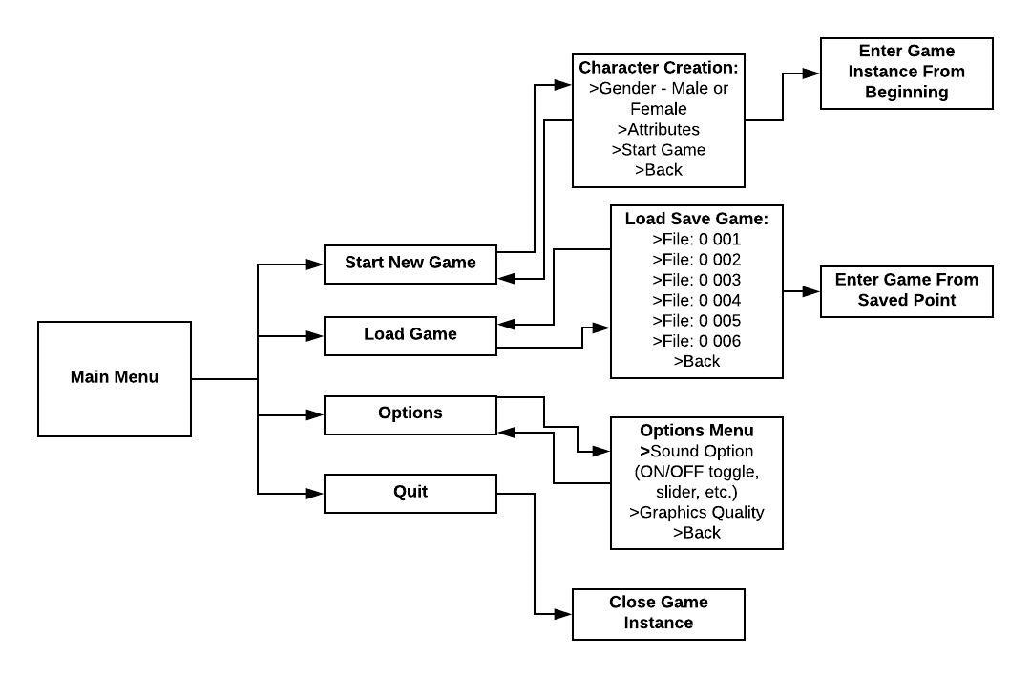

### Main Menu

* Start New Game
* Load Game
* Options
* Quit

### Character Creation

* Gender
* Attributes
* Start Game
* Back

### Load Game

* Load Save File: 0 001
* Load Save File: 0 002
* Load Save File: 0 003
* Load Save File: 0 004
* Load Save File: 0 005
* Load Save File: 0 006

### Options Menus

* Sound Option (ON/OFF toggle, slider, etc.)
* Graphics Quality
* Back

## Pause Menu Flow

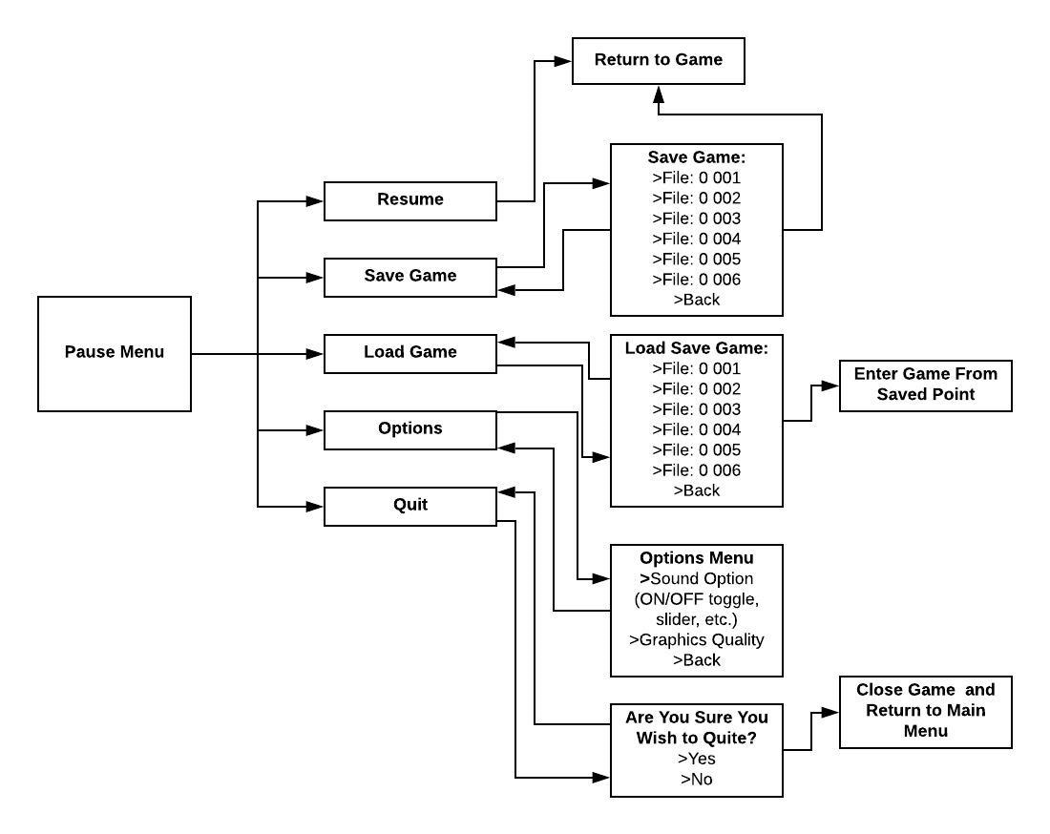

### Resume

* Exits the Pause Menu, returning the player to the game.

### Save Game

* Saves the progress at the desired Save Location. Successfully saving returns the player to the game.
* Using Back may bring the player back the the Pause Menu.

**The following Game State data should be saved:**

* The party’s exact location
* The party’s equipment
* The ongoing status effects of the party
* The location of nearby enemies
* The current disposition of the NPCs towards the Main Character
* What has been said to the NPCs

### Load Game

* Open the game from when the player last saved the game
* Return to the Pause Menu
  + 1. **Options**
* Sound Option (ON/OFF toggle, slider, etc.)
* Graphics Quality
* Back
  + 1. **Quit**
* Asks the Player if they really wish Quit
  + Exits the game to the Main Menu if Yes is selected
  + May return to the Pause menu if they select No

# Content

## Character Animations

* Walking Animation.
* Attacking Animation - One handed.
* Attacking Animation - Two handed.
* Attacking Animation - Polearm.
* Casting a Mystical Power.
* Casting a Ritual.
* Idle character.
  + Adjusting hat.
  + Playing with weapon belt
  + stretching
* Talking Animation.

## NPC List

|  |  |  |  |  |
| --- | --- | --- | --- | --- |
| **NPC Name** | **Attributes** | **Derived Statistics** | **Abilities** | **NPC Description** |
|  |  |  |  |  |
| **Rook, minstrel** | **Accurate** 11 (-1), **Cunning** 10 (0), **Discreet** 9 (+1), **Persuasive** 5 (+5), **Quick** 10 (0), **Resolute** 7 (+3), **Strong** 15 (-5), **Vigilant** 13 (-3) | **Armor**  2  **Defense** +1 (shield)  **Toughness** 15 **Pain Threshold** 8  **Shadow** (corruption: 0) | None | An inky black haired man with a crow beak nose, and wrapped in foppish, dog-eared, attire. He is a genteel character with a love of the drink, however, the goings on in Thorngard have left him disquieted. He claims to have been tutored by the elves of Ylhurandy, regardless of the truth, Blackhawk is well educated in the myths and legends of the area. |
| **Father Sarek** | **Accurate** 10 (0), **Cunning** 11 (-1), **Discreet** 5 (+5), **Persuasive** 17 (-7), **Quick** 9 (+1), **Resolute** 15 (-5), **Strong** 7 (+3), **Vigilant** 10 (0) | **Armor** 4  **Defense** +1  **Toughness** 10 **Pain Threshold** 4  **Shadow** (corruption: 0) | **Abilities** *Blessed Shield* (master), *Exceptionally Persuasive* (adept), *Exceptionally Resolute* (adept), *Leader* (master), *Loremaster* (novice), *Ritualist* (adept: *Heretic's Trail, Holy Smoke, Sanctifying Rite*)*, Prios' Burning Glass* (adept), *Theurgy* (master) | An aged man with snowy white hair and deep wrinkles entrenching his face. Father Sarek fervently believes that he is doing Prios’ will in burning the witches of Thorngard. He believes Prios is punishing Thorngard’s impure faith and that the deaths of these witches will appease him. The recent attacks have stoked Thorngard’s fear and outrage to the point that its people believe in Sarek’s murderous sermons. Father Sarek may choose to hire the player characters if he believes they are loyal to the church. |
| **Thaelda** | **Accurate** 10 (0), **Cunning** 13 (-3), **Discreet** 7 (+3), **Persuasive** 10 (0), **Quick** 9 (+1), **Resolute** 15 (-5), **Strong** 5 (+5), **Vigilant** 11 (-1) | **Armor** 2  **Defense** +1  **Toughness** 10 **Pain Threshold** 3  **Shadow** (corruption: 0) | **Abilities** *Alchemy* (adept), *Natural Warrior* (novice),  *Ritualist* (adept: *Quick Growth, Turn Weather, Witch Circle*), *Shapeshift* (adept), *Witchcraft* (adept) | A middle aged woman with grey in her long auburn braid and yearling wrinkles about her bright hazel eyes. Thaelda is a witch whose here to investigate the elves’s more violent behaviour as of late. She works as a scullery maid, cleaning the church of Prios, believing she could take a look at the church’s vault where she thinks there is a map to the elves court. If Thaelda can be convinced to trust the players, she hires them to assist her settle the elves and deal with the murderous priest. |
|  |  |  |  |  |

## SFX Assets

Overview.

* Door Locked: A single metallic thud.
* Door Opening: Squeaking of a hinge.
* Chest Locked: A brief repetitive metallic rattle, like a chain.
* Chest Opening: Squeaking of a hinge and then a wooden thump (the lid hitting the ground).
* Successful Attack that Damages: A bloody splattering sound.
* Successful Attack that Doesn’t do Damage: A wooden thud.
* Movement: Footsteps, dependent on the kind of ground. Clicking desired location causes the Main Character to mutter something from a small library (e.g. “Let's hurry up boys!”), this happens every four clicks or so.
  + Stone Terrain: Stoney thuds and scrapes.
  + Wooden Terrain: Wooden thuds, accompanied by the sporadic squeaking of loose floor boards.
  + Wet Terrain: Squishing sounds like sucking mud.
* Daytime: There are the sounds of bugs and birds singing
* Night Time: The sound of crickets chirping and owls hooting. Occasional sound of bushes ruffling.
* Moving Things Around in the Inventory: Clothy sounds, like the sound of a leather backpack being opened.

## Stages

* Thorngard,
  + **Music:** Old timey music. The closest thing to up-beat music in the game is heard here, as this is one of the few places where the player is safe from enemies. When the tone becomes darker, the music also takes on a more sinister tone.
  + **Voices:** The town is a murmur with the voices of people. The longer the game goes, the quieter the town gets as there are less and less people. When the player enters a building (other than the Inn) these voices die down.
* The Farmlands,
  + **Music:** The music in the Farmlands is similar to that of Thorngard but it's a little hasher. Similar to a western movie soundtrack. Hash cords building up the enthusiasm as the player leaves civilization.
* The Forest & The Deep Forest,
  + **Music:** Stark silence, this is an area filled with alien creatures, silence will add to the mystic. If the player starts to fight the elves, then some fast tempoed fighting music kicks up.
  + **Alien Language:** Sporadically placed snippets of an alien, elven language. To not over tax the player, these voices are not as frequent as the Voices in Thorngard, but they serve the same purpose. If the players are fighting, or have killed all the elves in this area, thes SFX doesn’t trigger.
  + **Animal Noises:** Twigs snapping and the occasional sound of leave being stepped on or branches being disturbed.
* Elven Hall,.
  + **Music:** Angelic, comforting music as the player progresses, but, upon starting a battle in earnest, the music starts to scream at the player. Fast paced music that almost sounds like a voice crying out in pain or for mercy.

# Controls

General Control Mechanism:

### Layout and Description

## Controls Overview

|  |  |
| --- | --- |
| Function | Button Event |
| Move player | W, A, S, D or arrow keys |
| Speak to NPC | F key |
| Attack NPC | Left Click |
| Pause Game / Menu | Click Pause Button on Screen, or P |
| Open Door | F key |
| Open Object | F key |
| Open Map | Click Map Button on the Screen, or M |
| Open Inventory | Click the Inventory Button on the Screen, or I |
| Interacting (objects, NPCs, etc) | F key |

# Marketing

### Short Descriptions/Taglines

* By the cover of night, death seeps into this harrowed town. Some fear, the wrath of their fiery god whose priest beckons them to burn their fellows, to crush foul witches under heel to cleanse their town of wickedness. Some wonder if the corruption of their souls, in truth, stems from that preacher who soaks his robes in the blood of “witches”. Some fear, that there is no answer. That the presence of death has made his home in their land. How will you decide?
* Ambria is a broken kingdom, threatened by wicked elves, murderous trolls, bloody goblins and fouler men.
* A bleak adventure for your grim pleasure.

### Positioning Strengths

* There isn’t a large pool of competing games in the isometric perspective RPG Market. The last major one was [Torment Numenera](https://tormentgame.com/) which had a mixed reception.
* Low risk due to being a small project and only having an online digital release.
* There is a growing fanbase for Symbaroum who are keen to support new content for the Pen and Paper RPG.
* There is a dedicated audience that harkens back to the days of creative RPGs that made use of storytelling via conversations as opposed to hack and slash violence.

### Target Audience

Primary – Teen boys 16+ The younger crowd is craving something darker than, what they perceive as, the elder roleplaying gamers. The desire something that appears to get back to the roots of older games. To be “Retro”. These are most likely to be the same crowd that funded the initial pen and paper game on Kickstarter.

Secondary – Men 30+ “Old School” gamers who are keen for a nostalgia high of the isometric perspective RPG era.